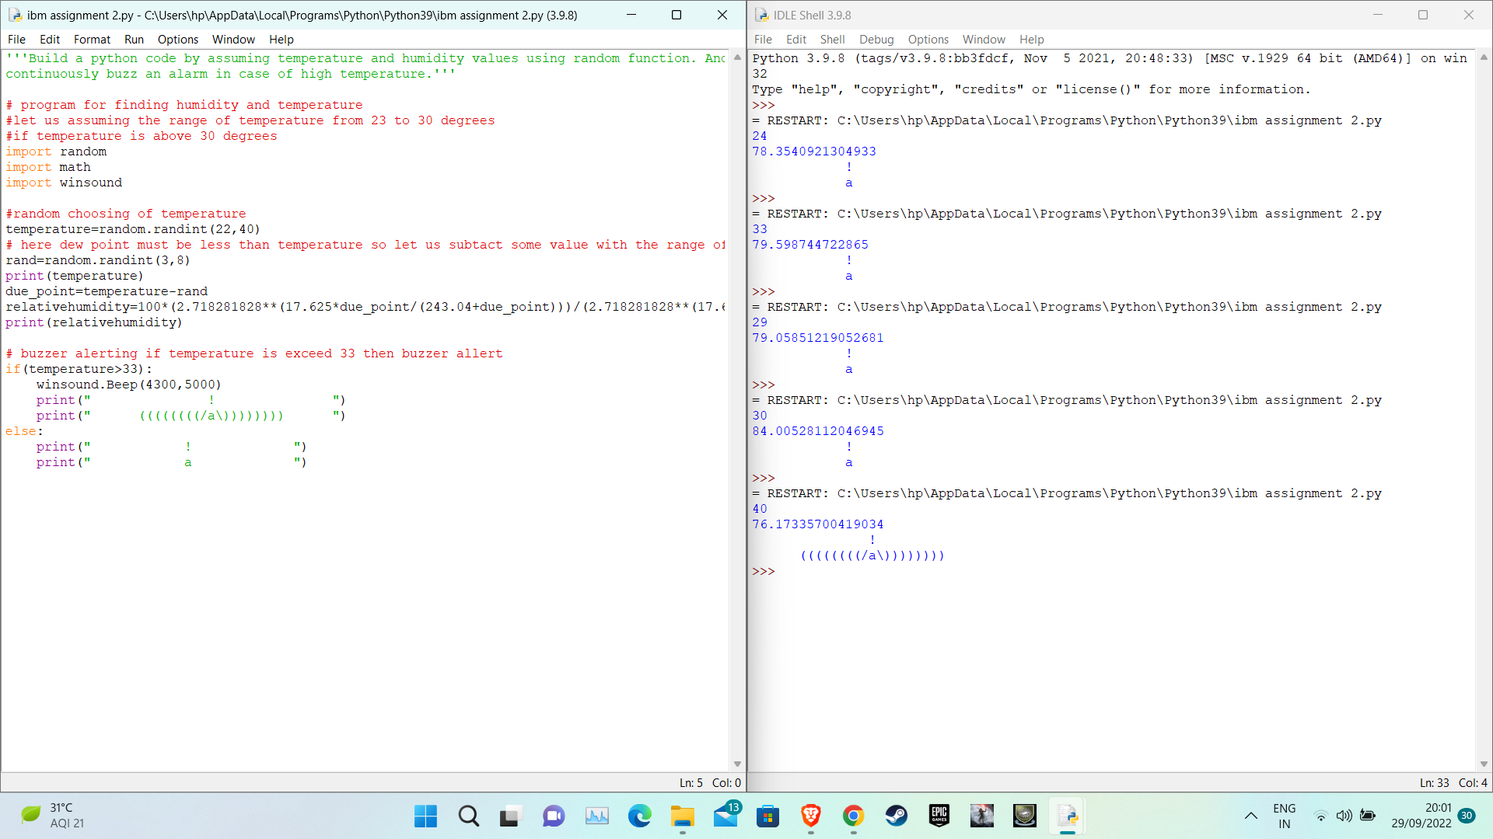

https://drive.google.com/file/d/1H2D7Wtihllknroej0L4MnJ1xpyyivS9F/view?usp=sharing